# Facultyof computersandInformationCairoUniversity



**Fall2021**

**CS241:OperatingSystem – 1Assignment 2:JavaSynchronization**

**Deadline& Submission:**

1. TheAssignmentis groupof4 Maximum.
2. At least one team member should submit the compressedgroup solution aszip filecontainingthe program under Blackboard=> (nameyourassignmentfile“Assignment_2_ID1_ID2_G#_G#.zip”).

e.g.Assignment_2 _20168383_201638838_G1_G2.zip

1. Thedeadlineforsubmittingthe solutionis 10 Dec. 2020 @11:59 PM.
2. Cheatingcould lead to serious consequences.
3. No submissions afterdeadline.

# Problemdescription:

* It s required to simulate a limited number of devices connected to a router’s Wi-Fi using Java threading and semaphore. Routers can design to limit the number of open connections. For example, a router may wish to have only N connections at any point in time. As soon as N connections are made, the router will not accept other incoming connection until an existing connection is released. In this project, I explained how semaphores can be used by a router to limit the number of concurrent connections.

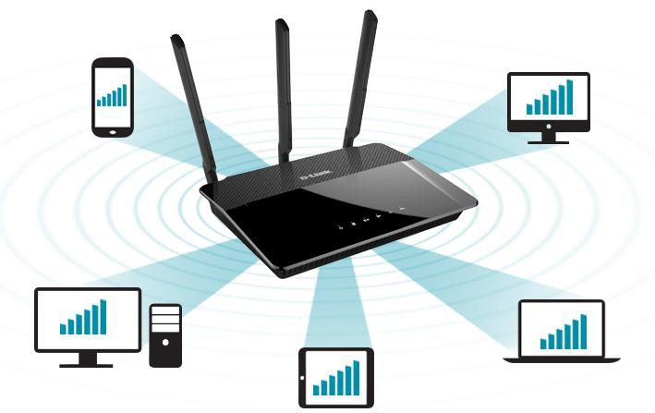

## Consider the followingrules:

* TheWi-Fi numberofconnecteddevices is initiallyempty.
* Ifaclientisloggedin(printamessagethataclienthasloggedin)andifitcanbeserved(meansthat it can reach the internet), thentheclient shouldperform thefollowingactivities:
  1. Connect
  2. Perform online activity
  3. Logout

## Note:these actionswillberepresentedbyprintedmessages,suchthatthereisarandomwaitingtimebetweentheprintedmessageswhenaclientconnects,dosomeonlineactivities andloggedout.

* Ifaclientarrivesandallconnectionsareoccupied,itmustwaituntiloneofthecurrentlyavailableclientsfinisheshis service andleave.
* Afteraclientfinisheshisservice,heleaveandoneofthewaitingclients(ifexist)willconnect to the internet.

# ProblemDesign

## You program must contain thefollowing classes:

1. **Router Class:** that contains a list of connection and methods to occupya connectionandrelease a connection.
2. **SemaphoreClass:**asgiven the synchronization lab.
3. **DeviceClass:**representdifferentdevices(threads)thatcanbeconnectedtotherouter;eachdevicehasitsownname(i.e.C1)andtype(i.e.mobile,pc,tablet...)anditmayperform threeactivities: connect,perform onlineactivityanddisconnect/logout.
4. **Network Class:** this classcontains themain method in which theuseris asked fortwoinputs:
   * ***N***: maxnumberof connections a routercan accept
   * ***TC***: total numberof devices that wishes to connect).
   * ***TC lines that contain***: name ofeachdevice,anditstype.

## ProgramOutput:

**You will print the output logs inafile, whichsimulatesthe executionorder ofthedevicesthreads and the printedmessagesofeachdevice.**

**Example:**

**Sample Input:**

What is number of WI-FIConnections?2

What is numberof devicesClientswant to connect?4

C1 mobile C2 tabletC3 pc

C4 pc

**Sample output:**(Note:output depends on theorder oftheexecutions of thethreads)

* (C1)(mobile)arrived
* (C2)(tablet)arrived
* Connection1:C1Occupied
* Connection2:C2Occupied
* C4(pc)arrived and waiting
* C3(pc)arrived and waiting
* Connection1:C1performsonlineactivity
* Connection2:C2performsonlineactivity
* Connection1:C1Logged out
* Connection 1:C4Occupied
* Connection 1:C4performs online activity
* Connection2:C2Logged out
* Connection2:C3Occupied

# Gradingcriteria:

|  |  |
| --- | --- |
| **RouterClass** | **15** |
| **SemaphoreClass** | **5** |
| **DeviceClass** | **10** |
| **NetworkClass** | **10** |
| **Outputvalidorder ( CodeRunProperly)** | **20** |
| **GUI -Bonus(Thatshowsthe behaviorofconnectionswhen occupied orreleasedby a particulardevice)** | **10** |